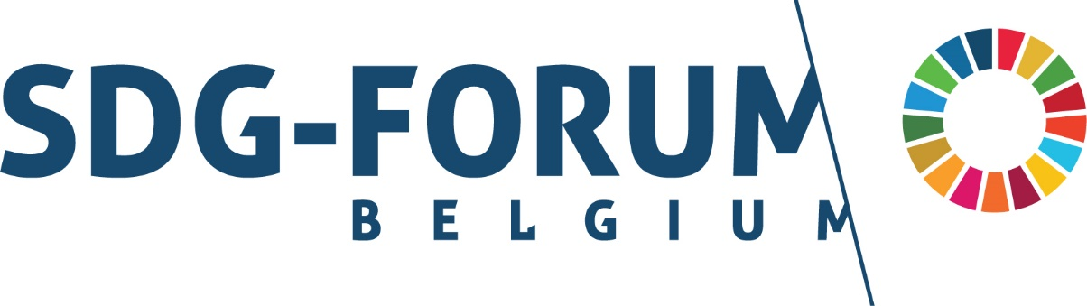

**Open-call: organise a workshop at the SDG Forum 2024   
(5th and 6th November 2024)**

This form should be submitted back to the following mail addresses by Saturday 15 June at the latest: [info@sdgs.be](mailto:info@sdgs.be); [joy.deklerck@fido.fed.be](mailto:joy.deklerck@fido.fed.be); [dieter.vanderbeke@fido.fed.be](mailto:dieter.vanderbeke@fido.fed.be)

|  |  |
| --- | --- |
| **Organisation** |  |
| **Title of workshop** |  |
| **Theme** (link with SDGs) |  |
| **Describe the outline of the workshop in max. 5 lines** |  |
| **Describe the format** (Presentation, panel, group discussion, action, etc) **of the workshop in max. 5 lines** |  |
| **In what way does the workshop have a creative, innovative or interactive approach?** |  |
| **What is the relevance of this workshop?** |  |
| **Who is the intended audience for the workshop?** |  |
| **Expected number of participants\*** |  |
| **Is the workshop a collaboration with other organisations?** |  |
| **Indicate spoken languages during the workshop** | NL – FR – ENG (language combinations possible and encouraged) |
| **Day on which the workshop can take place** (if possible on both days, please indicate both days) | Tuesday 5 November  Wednesday 6 November |
| **Additional remarks** |  |

|  |
| --- |
| A microphone, projection facilities and a flipchart are provided. A laptop and other equipment should be brought by yourself or discussed with the event organiser. |

* Important to indicate if there is a maximum number of participants because of e.g. an interactive workshop format.

**Selection criteria**

Workshops will be selected based on the criteria below. Please keep the selection criteria in mind when filling the registration form.

|  |  |
| --- | --- |
| 1. **Relevance** | The extent to which the workshop contributes to one or more Sustainable Development Goals |
| 1. **Theme** | The originality of the chosen theme in relation to sustainable development, e.g. business and human rights, sustainability, youth participation, biodiversity, finance,...   * Focus on creativity, innovation and interaction |
| 1. **Purpose** | Action-oriented and/or awareness-raising |
| 1. **Target audience** | Clarification on the intended audience of the workshop, such as policymakers, business leaders, civil society organisations, young people, etc. |
| 1. **Diversity, inclusion and leave no one behind principle** | The extent to which diversity, inclusion or the leave no one behind principle is taken into account during the workshop? |
| 1. **Collaboration with multiple organisations** | The added value of collaboration between different organisations to strengthen the workshop and increase impact |

For your information: a workshop lasts 1 hour and 15 minutes.